|  |
| --- |
| SENG 403: Software Development in teams and organizations |
| Iteration #3 Report |
| Group 4 |
|  |
| **James Bertram, Thomas Frampton, Ekaterina Grekova, Matthew Jones, Andrew Midwinter, Mark Mullen** |
| **4/9/2012** |

|  |
| --- |
|  |

Contents

Executive Summary 2

Project Summary 3

Progress during Iteration 3 5

Weekly Snapshots of the Storyboard during Iteration 3 9

System Evaluation 11

Work Distribution 12

Appendix A – All Stories 14

Appendix B – Backlog 15

# Figures

Figure 1. Velocity during Iteration 1, 2 and 3 5

Figure 2. Retrospective Meeting - Brainstorming ideas (left to right - Thomas Frampton, James Bertram, Mark Mullen, Andrew Midwinter) 6

Figure 3. Retrospective Meeting - Brainstormed ideas 7

Figure 4. Retrospective Meeting - Categorized ideas and voted for the category 7

Figure 5. Retrospective Meeting - Category that had the majority of votes 8

Figure 6. Retrospective Meeting - Identified Actions (hand - Thomas Frampton, left to right - Mark Mullen, Andrew Midwinter, James Bertram) 8

Figure 7. Storyboard snapshot at the beginning of week 1 in Iteration 3 9

Figure 8. Storyboard snapshot at the beginning of week 2 in Iteration 3 10

Figure 9. Storyboard snapshot at the beginning of week 3 in Iteration 3 10

Figure 10. Storyboard snapshot at the beginning of week 4 in Iteration 3 11

# Tables

Table 1. Summary with what was planned and achieved throughout the project 4

Table 2. All stories with their priority and points 14

# Executive Summary

The report presents the deliverables of Iteration 3 and system evaluation. The work progress during Iteration 3 is present in the Weekly Snapshot of the Storyboard section. After discussions among the group and with the customers, the plan for Iteration 3 was developed and executed. This report contains an overview of the project and the system. The tasks were managed in a fair manner, and appropriate feedback was provided to the group members.

# Project Summary

presents the summary of what was planned and achieved throughout the entire project. All stories that were planned for Iteration 1, 2 and 3 are presented in that table along with the tasks that were created for completing that story. Each task was assigned a priority based on system’s requirements and our expertise. If a task was not completed during the iteration, it was pushed to the next iteration unless it was no longer required.

Table . Summary with what was planned and achieved throughout the project

|  |  |  |  |  |  |
| --- | --- | --- | --- | --- | --- |
| **Iteration Number** | **Planned Stories** | | **Planned Tasks** | **Priority** | **Implemented** |
| **1** | 1.1 | Authentication (login) | Encrypt user password | Must | Yes |
|  |  |  | Save user information | Must | Yes |
|  | 1.2 | Track patient information | Create patient | Must | Yes |
|  |  |  | Edit patient | Must | Yes |
| **2** | 2.1 | Administrator assigns nurse to ward | Assign nurses to wards | Must | Yes |
|  | 2.2 | Encrypt patient information | Encrypt patient information | Must | No |
|  | 2.3 | Patient changes beds | Track rooms and beds | Should | Yes |
|  |  |  | Assign patients to rooms and beds | Must | Yes |
|  | 2.4 | Track nurse information | Create nurse | Must | Yes |
|  |  |  | Edit nurse | Must | Yes |
|  |  |  | Delete nurse | Should | Yes |
|  | 2.5 | Admin or nurse can assign patient to a room | Permissions | Should | No |
|  | 2.6 | New patients are placed in a priority queue | Place patients in a priority queue | Must | Yes |
|  | 2.7 | Nurse can checkout patient | Add "In Hospital" checkbox | Must | Yes |
|  | 2.8 | View patients in ward |  | Must | Yes |
| **3** | 3.1 | Track patients information | Add validation of user input | Must | Yes |
|  | 3.2 | Nurse checks in/out patients | Add validation of user input | Must | Yes |
|  | 3.3 | Patients change bed | Add validation of user input | Must | Yes |
|  | 3.4 | New patients are placed in a priority queue | Add validation of user input | Must | Yes |
|  | 3.5 | A doctor or a head nurse can enter nurses' information | Implement permissions | Should | Yes |
|  | 3.6 | Assign nurses to wards |  | Must | Yes |
|  | 3.7 | Nurses can view information of the patients that they are in charge of | Implement permissions | Should | Yes |
|  | 3.8 | A secretary can enter patients' information when they arrive | Implement permissions | Should | Yes |
|  | 3.9 | An administrator assigns a nurse to a ward | Implement permissions | Should | Yes |
|  | 3.1 | An administrator or a nurse assigns a patient to a room | Implement permissions | Should | Yes |
|  | 3.11 | A doctor or a nurse can search for a patient | Implement permissions | Should | Yes |
|  |  |  | Search for patients | Must | Yes |
|  | 3.12 | View nurses in wards | Show ward names instead of numbers in the table | Must | Yes |

# Progress during Iteration 3

During Iteration 3, we mainly focused on feedback that was provided by the customers at the end of Iteration 2. We carefully analyzed the customer’s critique and created appropriate tasks. Then those tasks were delegated to the team members. Also, we fixed several defects that were found during QA testing. Some of the defects include validations of user’s input. That is why the velocity during Iteration 3 is lower in comparison to the velocity during Iteration 2.

No system requirements were changed except for user interface. Some changes were requested in order to improve usability and appearance of the system.

Figure . Velocity during Iteration 1, 2 and 3

At the end of Iteration 3, a retrospective meeting was arranged for the group. The goal of the meeting was to learn from the previous experience and find ways to improve future efforts. We followed the procedure defined in the lecture slides. Figures 2-6 illustrate some of the stages during the retrospective meeting. During the meeting, Communication category got the majority of votes. We analyzed each card that was in that category. Those cards were as follow:

* Good:
  + Members were respectful and cooperative
* Bad:
  + Communications with suppliers group (reports)
  + Lack of team contract
  + While implementing features, members did not communicate as much as they could have
  + Communication

Each card was addressed and appropriate actions were identified. The following are the main actions that were discussed during the meeting:

* Include everyone in the emails distribution between suppliers and our team
* Create communication protocols
* Spend more time developing together
* Create team contract

Figure . Retrospective Meeting - Brainstorming ideas (left to right - Thomas Frampton, James Bertram, Mark Mullen, Andrew Midwinter)

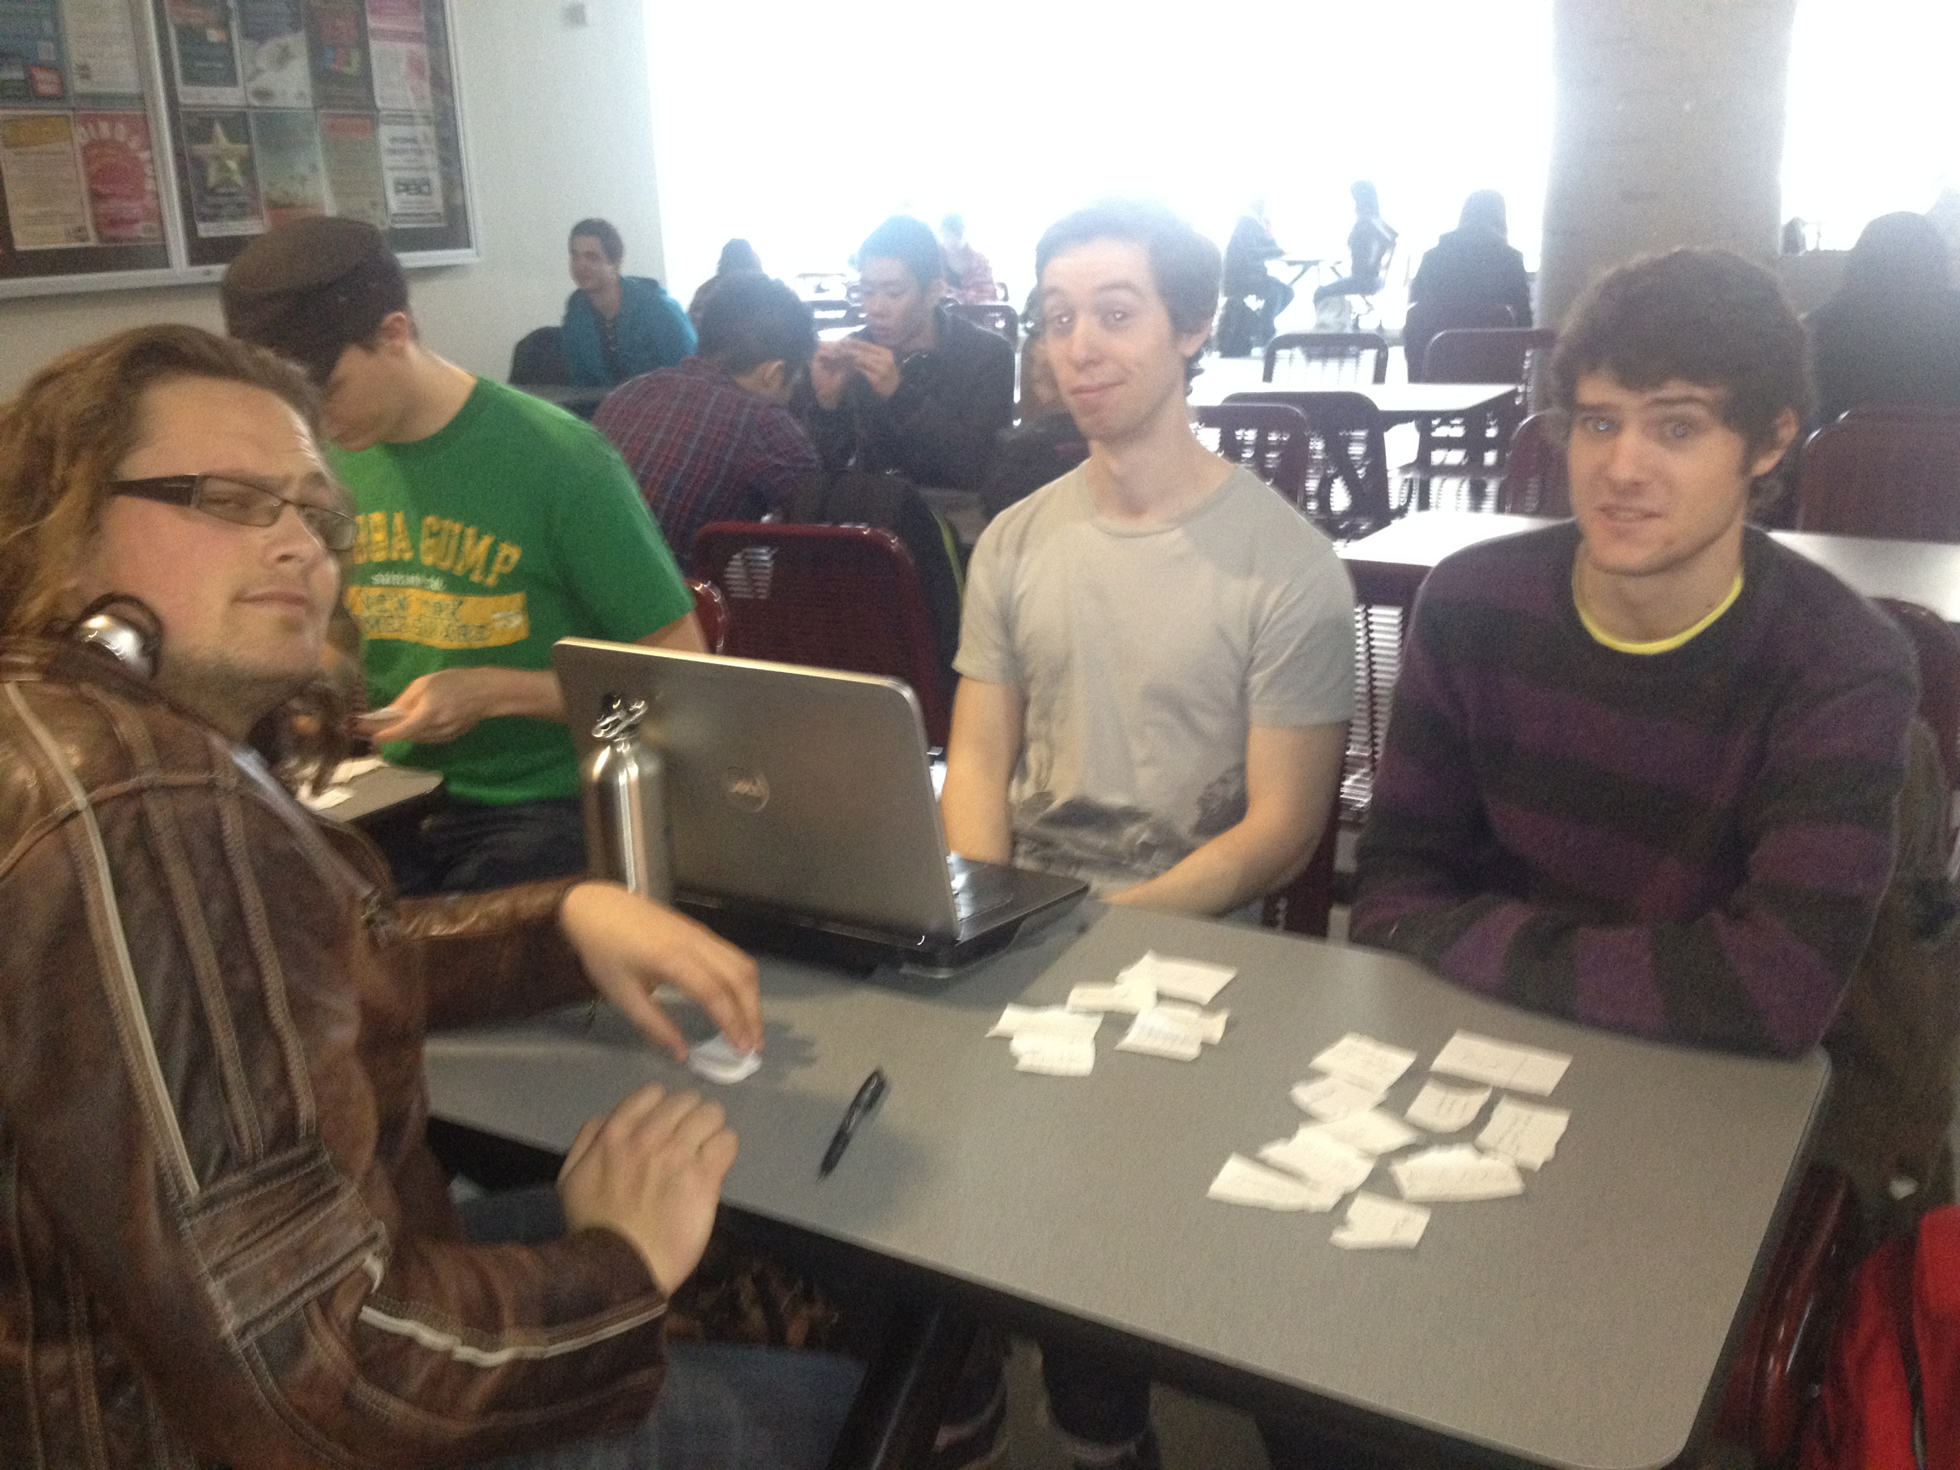

Figure . Retrospective Meeting - Brainstormed ideas

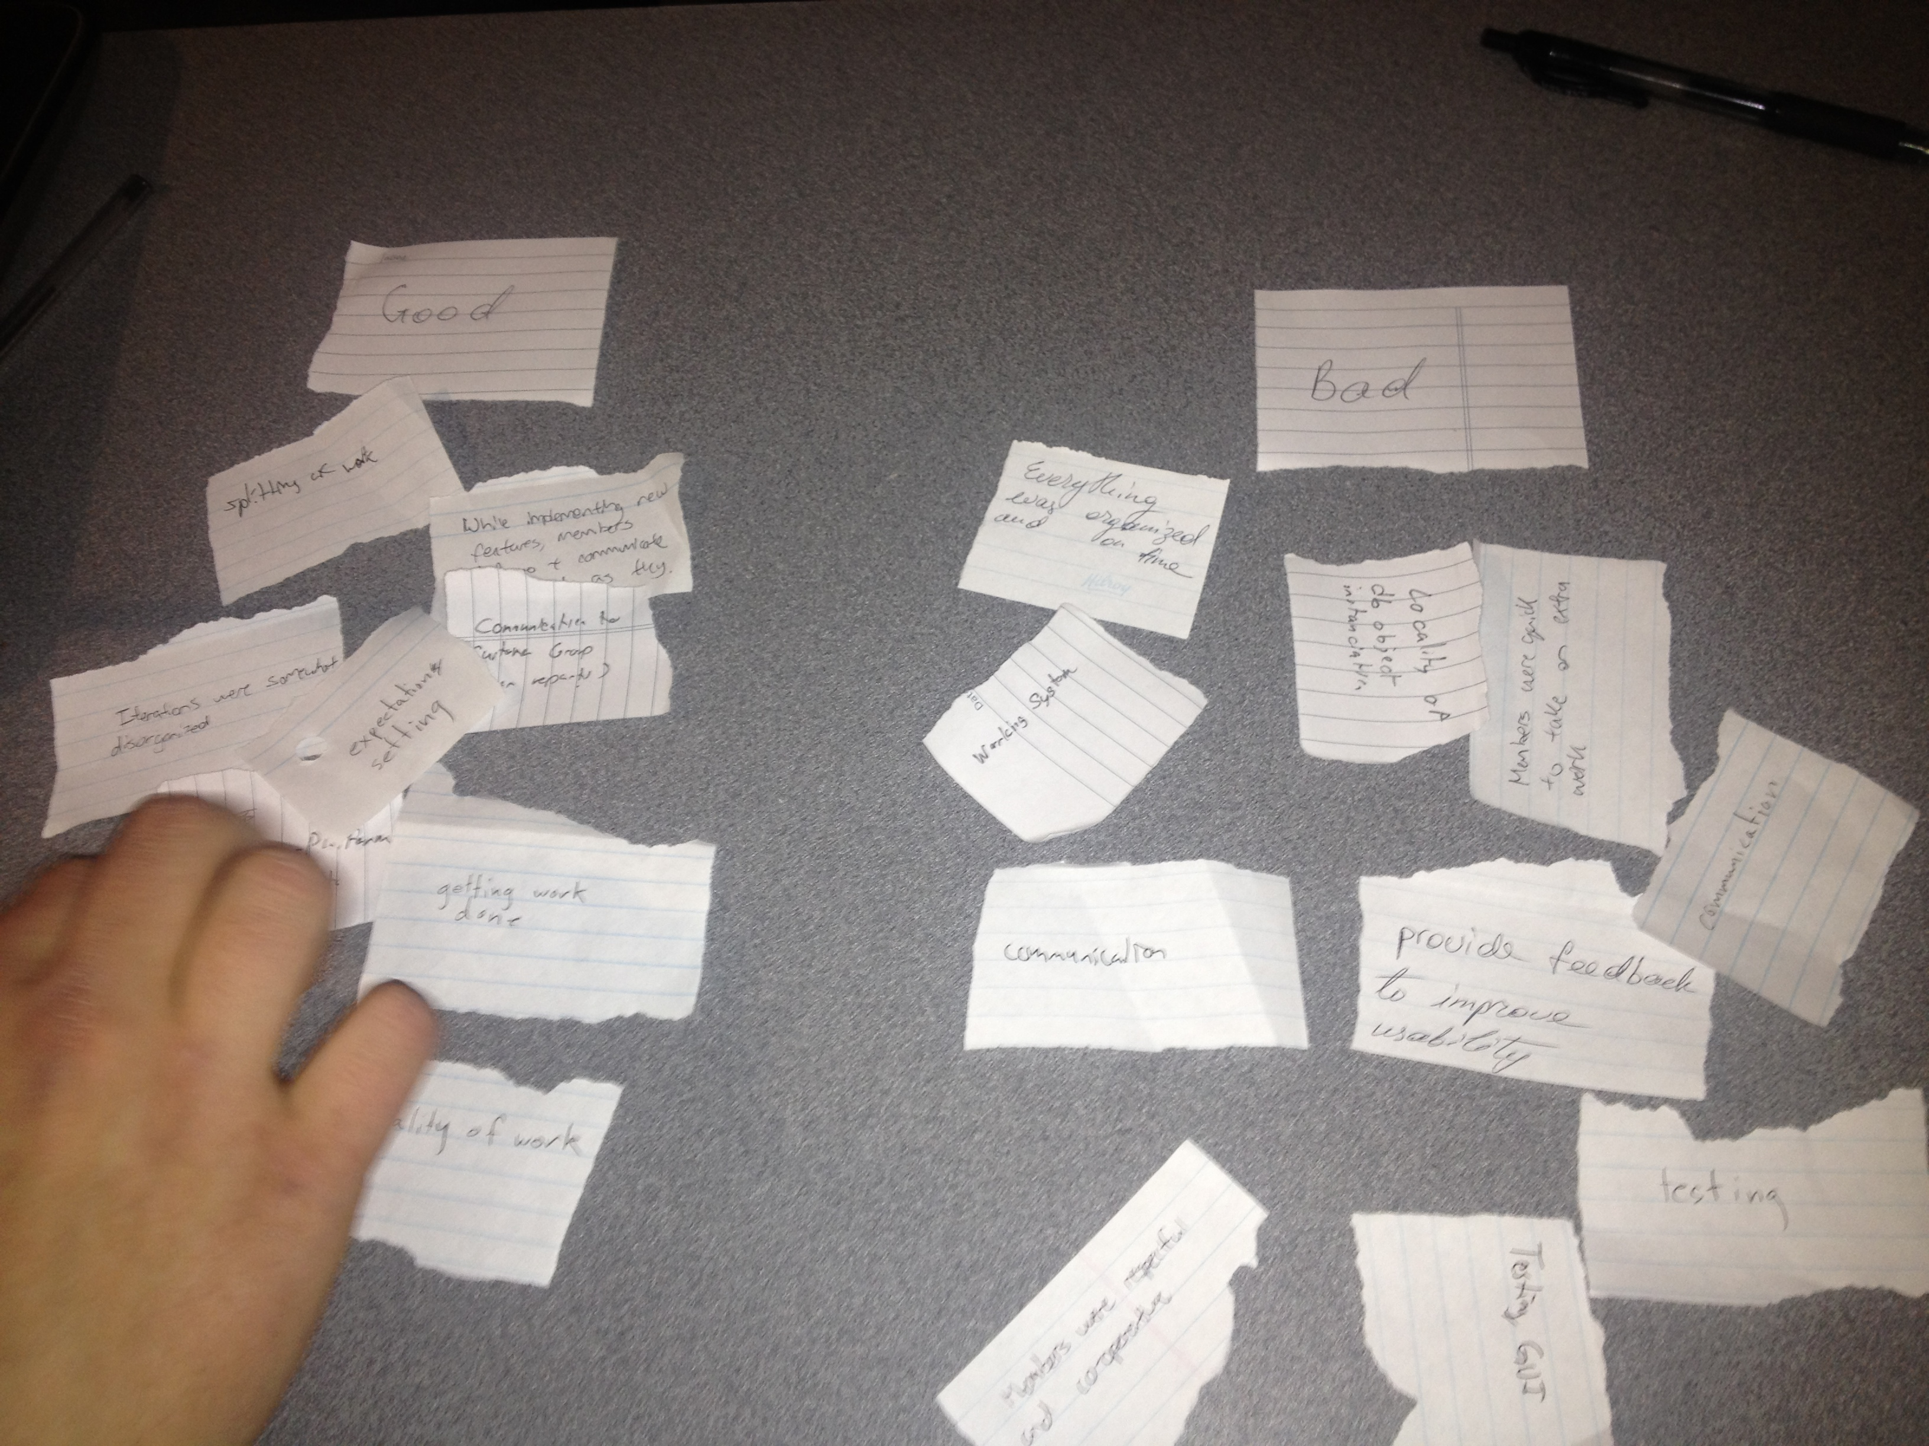

Figure . Retrospective Meeting - Categorized ideas and voted for the category

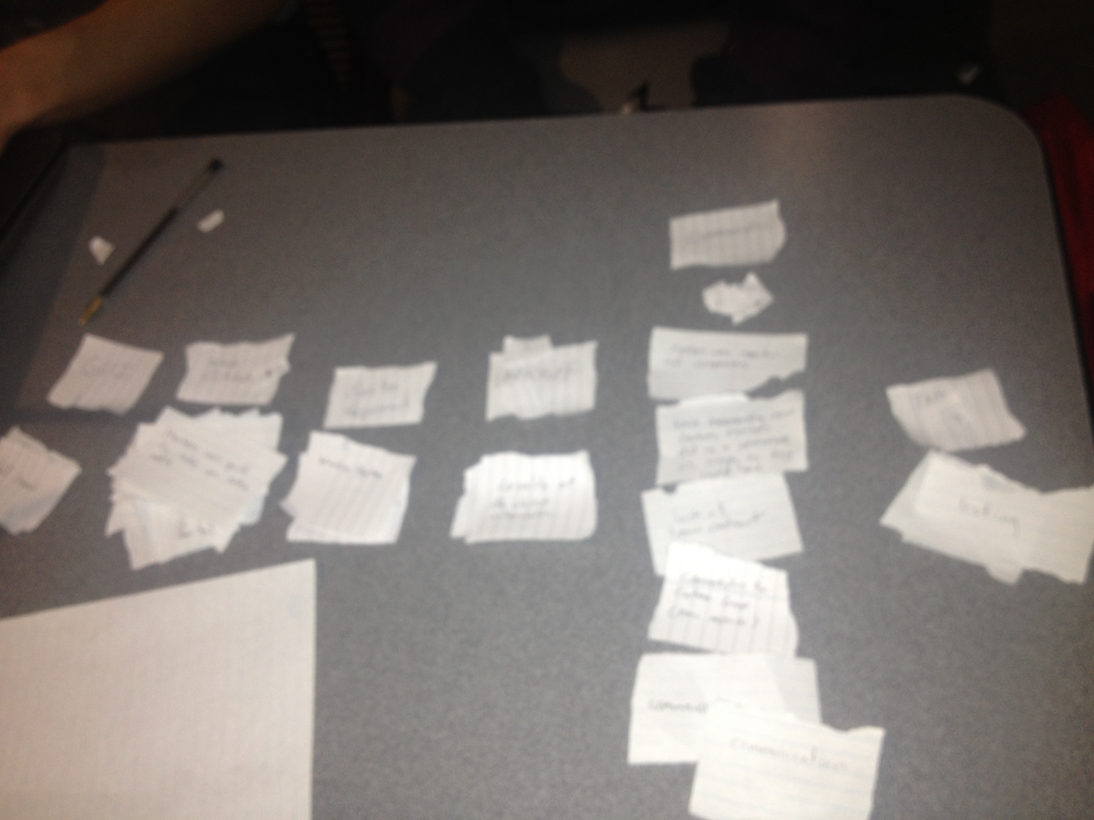

Figure . Retrospective Meeting - Category that had the majority of votes

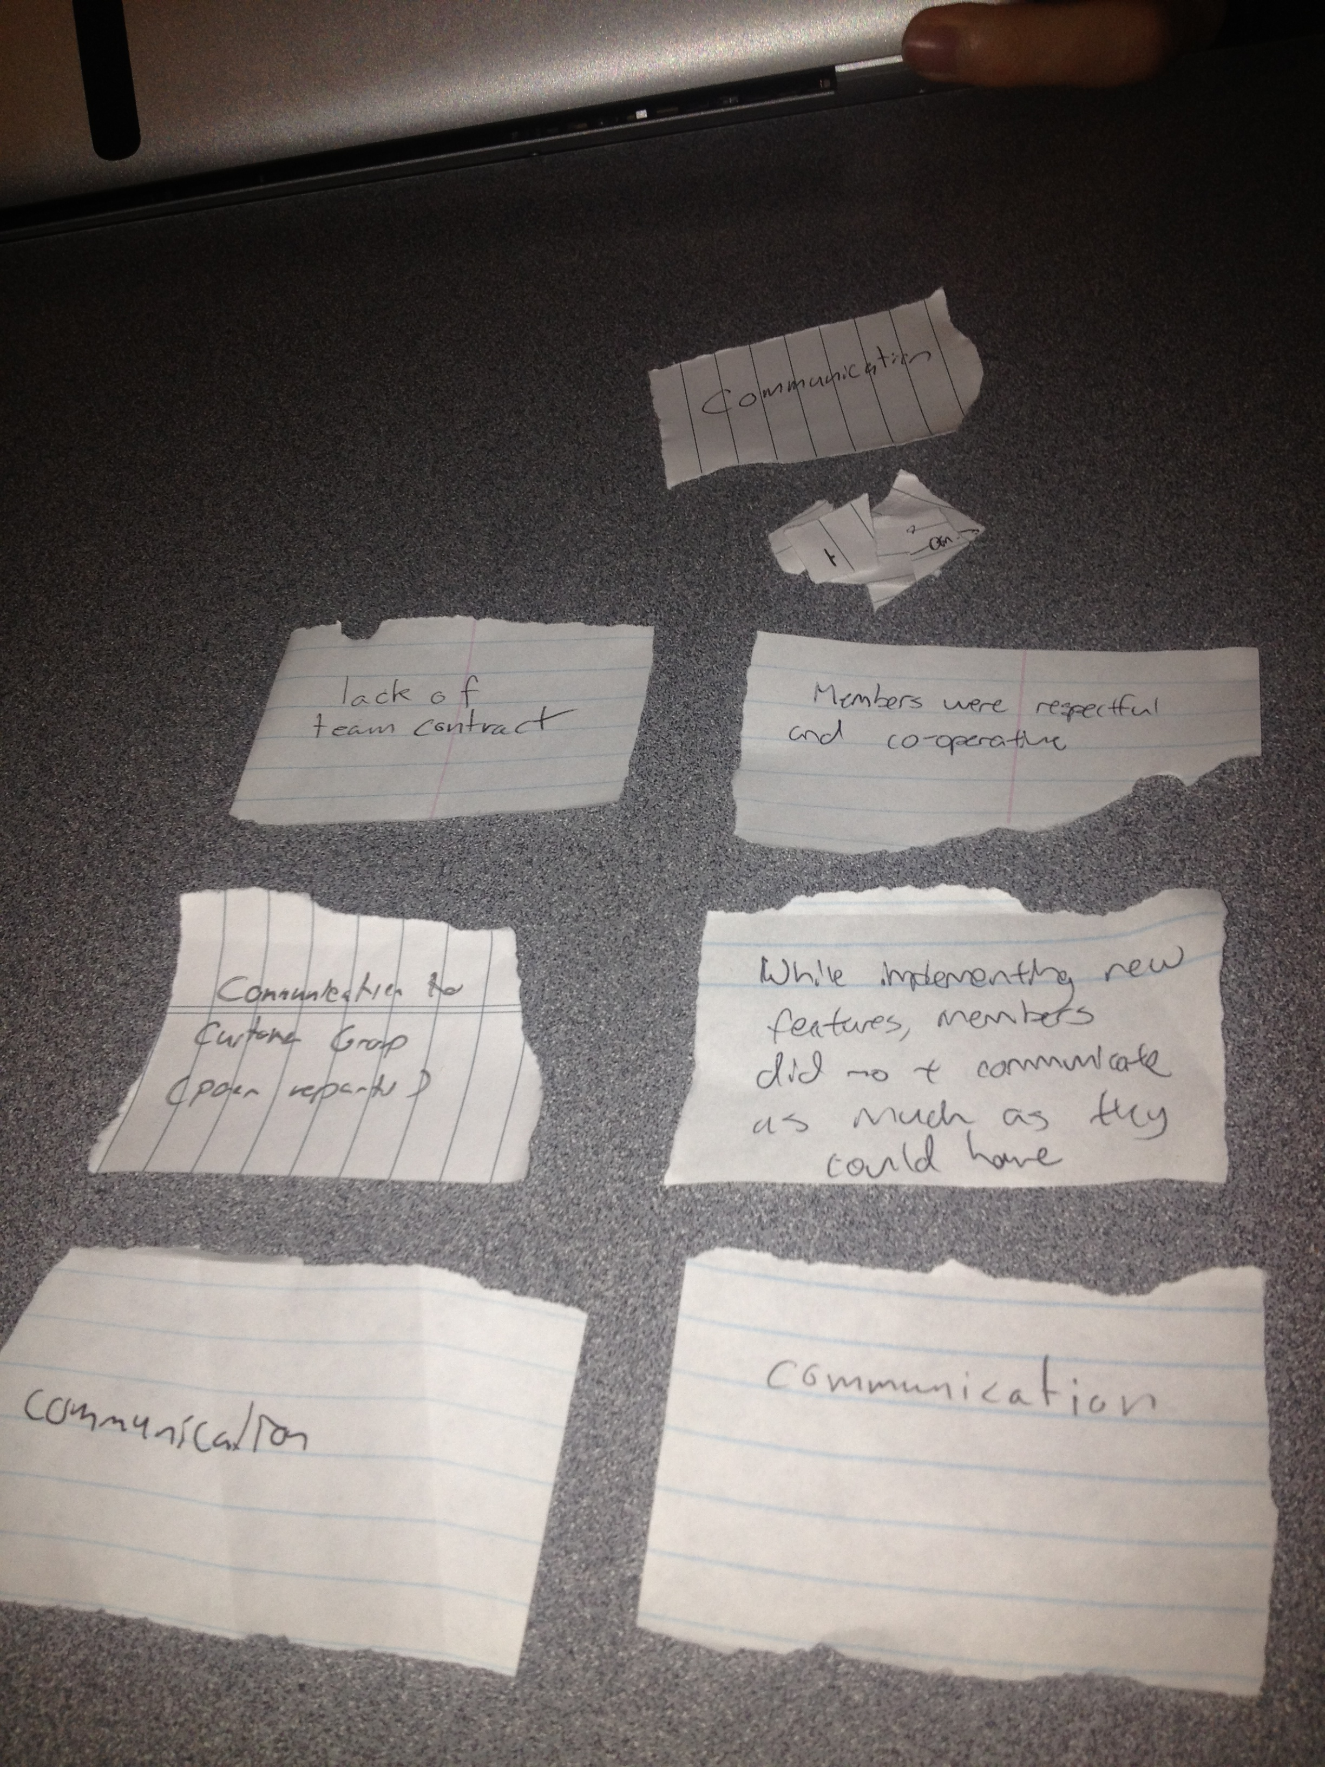

Figure . Retrospective Meeting - Identified Actions (hand - Thomas Frampton, left to right - Mark Mullen, Andrew Midwinter, James Bertram)

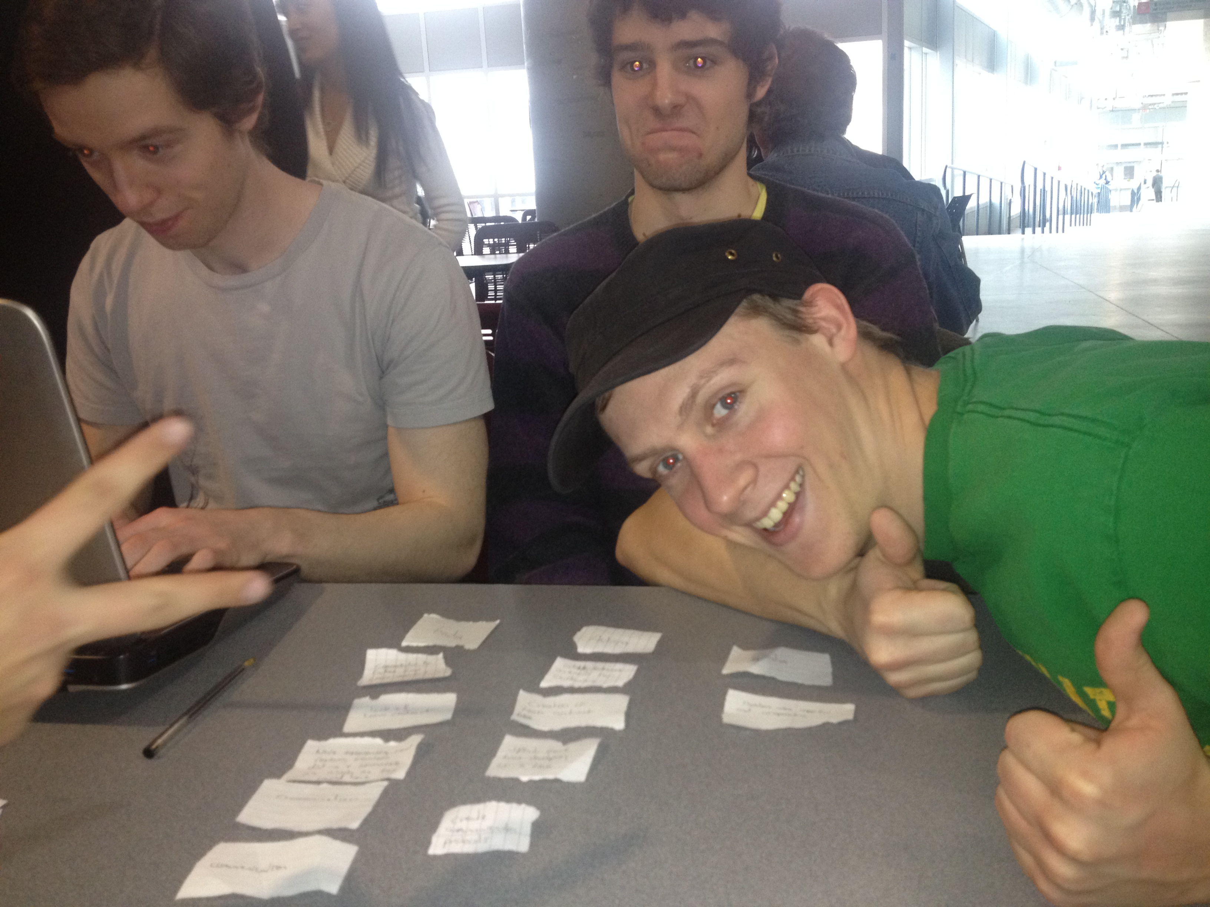

## Weekly Snapshots of the Storyboard during Iteration 3

During Iteration 3, different tasks were assigned to group members. We discussed those tasks and upon completion, we provided each other with the feedback for further improvements. The following snapshots of the storyboard illustrate how the project was progressing during Iteration 3. The snapshots were taken at the beginning of each week.

Figure 7. Storyboard snapshot at the beginning of week 1 in Iteration 3

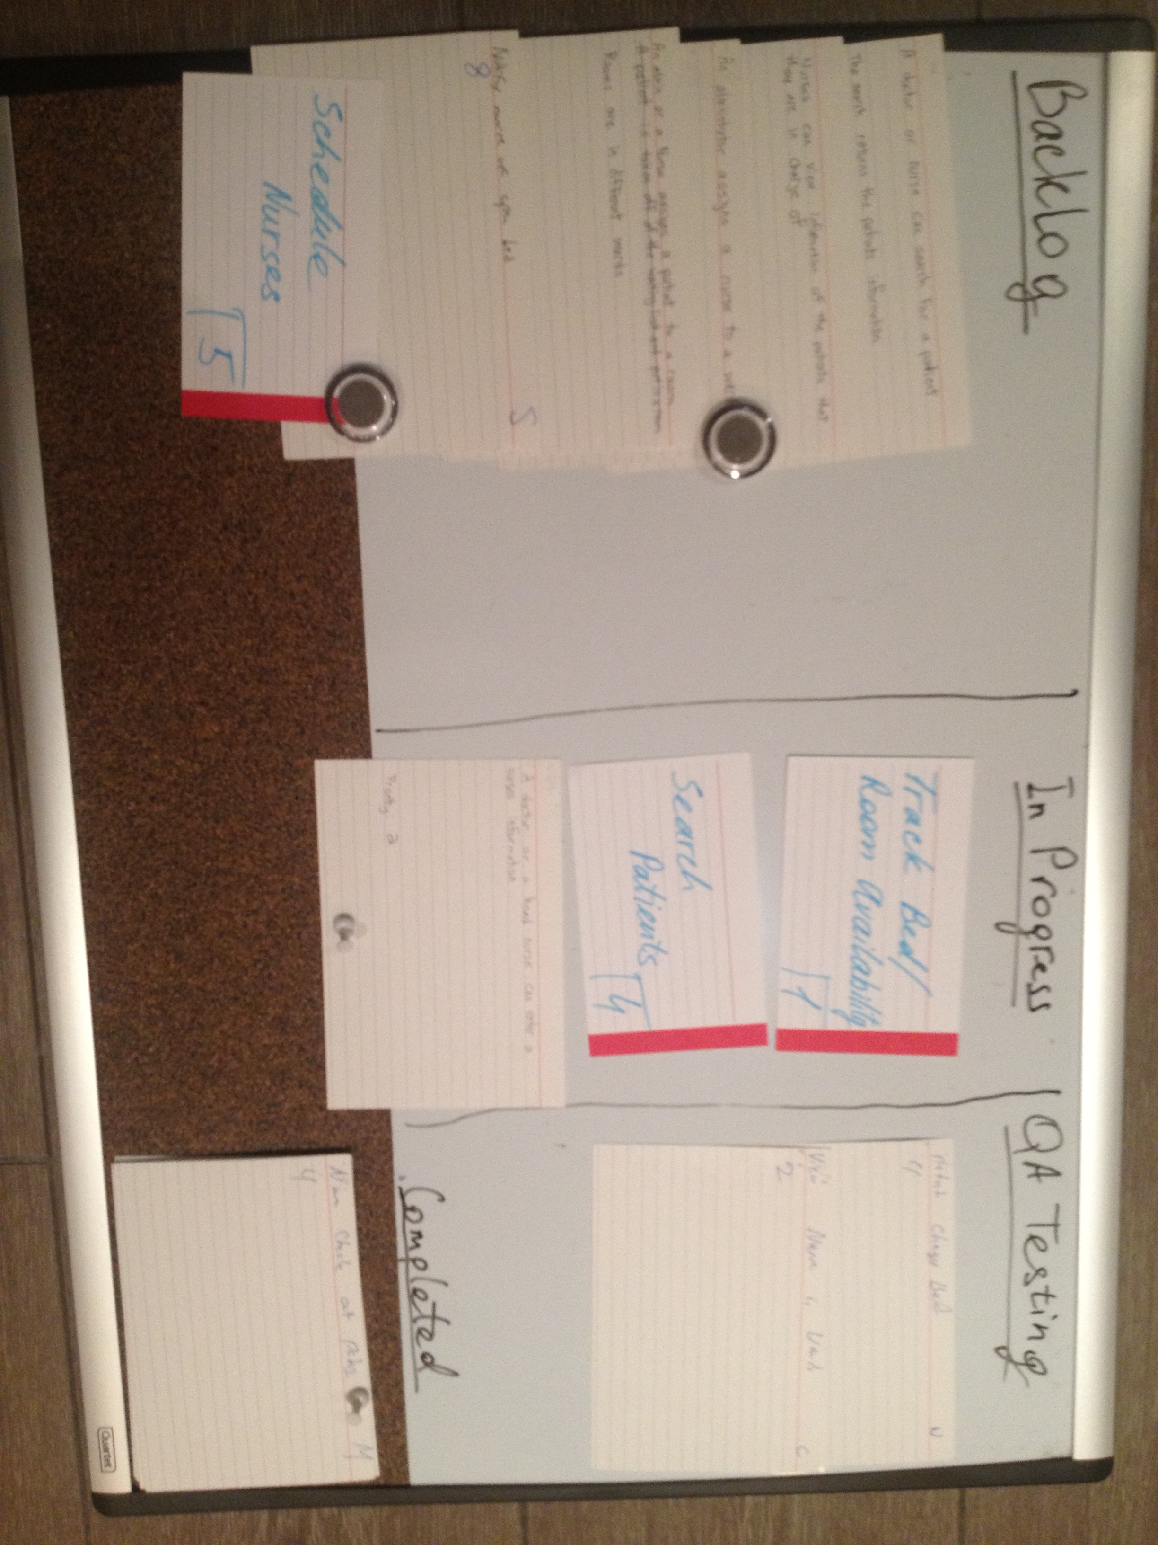

Figure 8. Storyboard snapshot at the beginning of week 2 in Iteration 3

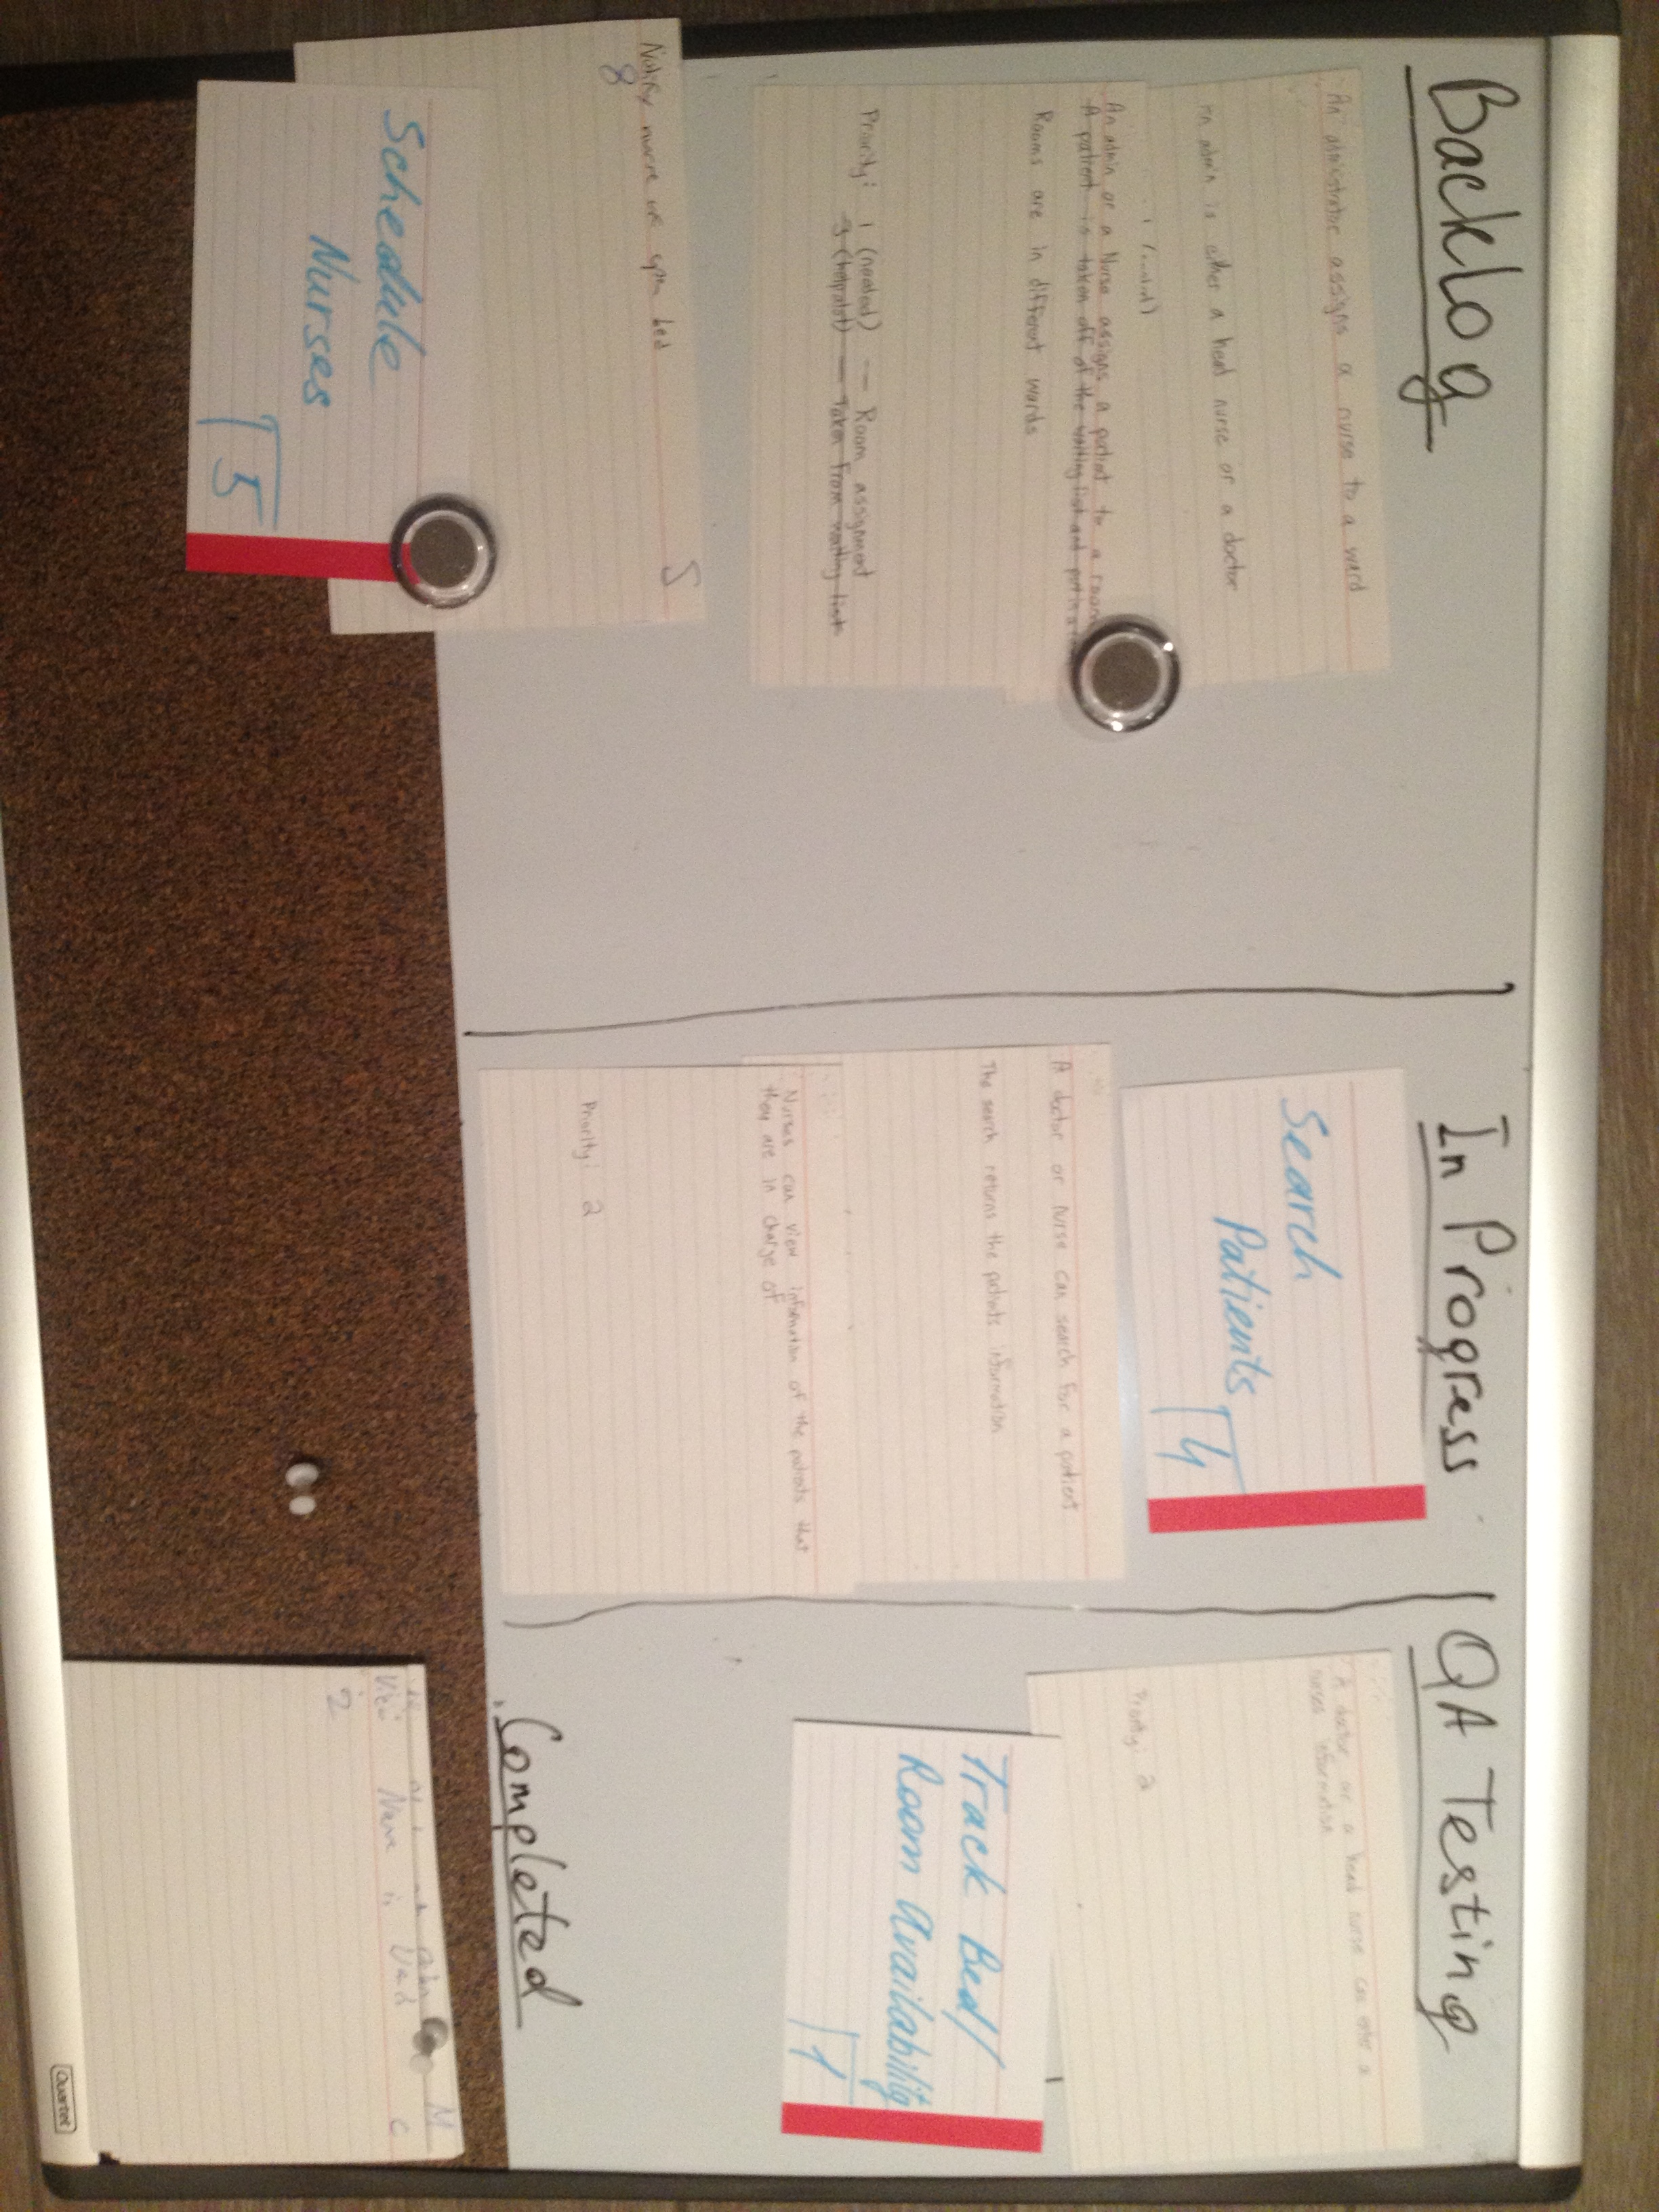

Figure 9. Storyboard snapshot at the beginning of week 3 in Iteration 3

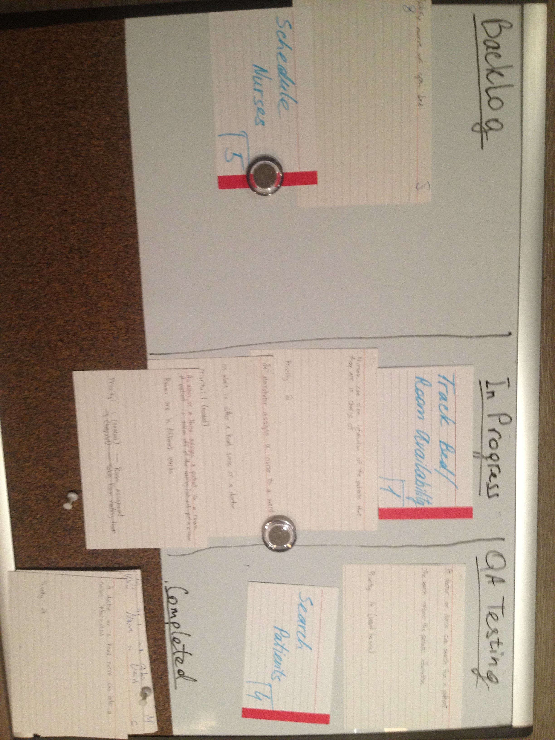

Figure 10. Storyboard snapshot at the beginning of week 4 in Iteration 3

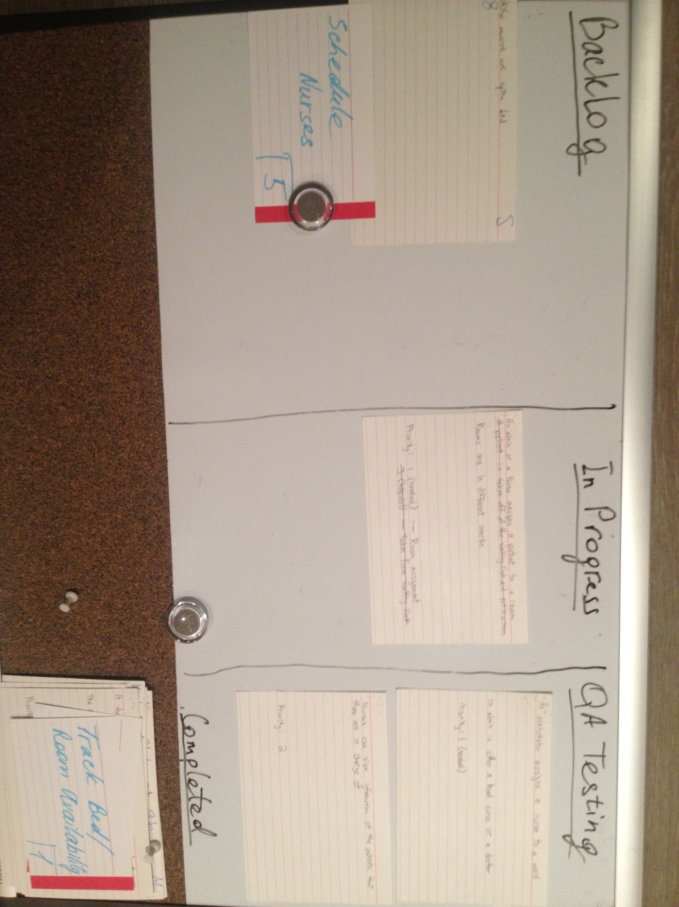

# System Evaluation

During Iteration 0, we selected the base architecture. However, the architecture seemed complex, so appropriate changes were made to the architecture. We use View - Controller – Models architecture. It is capable of handling the system requirements without introducing problems with code organization. Everyone in the team familiarized themselves with the architecture in order to place different logic in appropriate classes.

The chosen architecture is extensible to expand and enhance the system. That is useful in the case as requirements evolve and new requirements are discovered. The existing design principles allow adding new features easily. The extensibility of the developed system will be especially useful during maintenance phase.

The selected base architecture allows straightforward approach to write unit tests for each class except for GUI classes. A team member, who was responsible for implementing a feature, was also responsible for writing unit tests. Our adequacy criteria was to test at least “happy” paths due to time constraints. Once the feature was implemented and there were unit tests for it, an assigned QA tester would perform manual testing to ensure that it meets the requirements.

It was very important to write clean and readable code. We continuously strived for improving the readability by code refactoring. Some code still should be refactored, but overall our code seems sufficient for the available time budget.

Among small issues that exist in the system, the main issue is system modularity. The issues related to modularity have been brought up to the team during one of the meetings. Weak parts of the code were pointed out, and a solution to that was proposed. That way the code would be broken down into separate components and decrease code duplication. However, this solution will be a task for a next iteration due to time constraints.

Various development tools were used during the development process. Those tools were selected during Iteration 0 and have not been changed. Those tools allowed us to make changes to the same files and at the same time, keep the source code in one place and develop tested features. Peer support was provided to team members that needed assistance with using certain development tools. If none could be provided, we would investigate those issues and find a way to complete our tasks.

# Work Distribution

**Thomas**

Tasks:

* Implement feature 1.5 (assign nurses to wards)
* Implement permissions (allow certain functionality to user with different roles)

Stories:

* + A doctor or a head nurse can enter nurses’ information
  + Nurses can view information of the patients that they are in charge of
  + A secretary can enter patients’ information when they arrive
  + An administrator assigns a nurse to a ward
  + An admin or a nurse assigns a patient to a room

**Mark**

Tasks:

* + Show ward names instead of numbers in the table on the Main screen
  + Write critique of the suppliers’ report
  + Track rooms and beds availability

Stories:

* + View nurses in wards

**Andrew**

Tasks:

* + Validate users’ input when saving changes

Stories:

* + Track patients information
  + Nurse checks in/out patients
  + Patients change bed
  + New patients are placed in a priority queue

**Matthew**

Tasks:

* + Refactoring
  + Implement unit tests
  + Integration testing

**Ekaterina**

Tasks:

* + Resolve issues with UI
  + Remove unnecessary columns from the tables and show that data on the side on the Main screen
  + Write report
  + QA testing

**James**

Tasks:

* + Implement feature 4.1 (search for patients)

Stories

* + A doctor or nurse can search for a patient

# Appendix A – All Stories

Table 2. All stories with their priority and points

|  |  |  |  |
| --- | --- | --- | --- |
| **Number** | **Story** | **Priority** | **Points** |
| **1.1** | Assigning patients to rooms (This feature allows nurses or administrators to assign patients to specific rooms.) | **1** | **3** |
| **1.2** | Tracking Patient Information (This feature allows administrators to enter, edit, and view information about patients.) | **1** | **4** |
| **1.3** | Tracking Bed/Room availability (This feature keeps track of which beds and rooms are currently available, and which are currently occupied.) | **1** | **5** |
| **1.4** | Assigning Nurses to Wards (This feature allows administrators to assign nurses to wards.) | **1** | **3** |
| **1.5** | Encrypting of Patient Information (Patient information will be encrypted for security.) | **1** | **1** |
| **2.1** | Tracking Nurse Information (Doctors and head nurses can enter, edit nurses' information.) | **2** | **4** |
| **3.1** | Placing Patients in a Priority Queue (Patients will be placed in a priority queue to order them by the severity of their illness or injury.) | **3** | **5** |
| **4.1** | Searching for Patients (Nurses and Doctors can search for information about a specific patient.) | **4** | **3** |
| **5.1** | Scheduling Nurses (Administrators can create schedules to assign nurses to shifts.) | **5** | **5** |

# Appendix B – Backlog

|  |  |  |  |
| --- | --- | --- | --- |
| **Number** | **Story** | **Priority** | **Points** |
| **1.3** | Tracking Bed/Room availability (This feature keeps track of which beds and rooms are currently available, and which are currently occupied.) | **1** | **5** |
| **1.5** | Encrypting of Patient Information (Patient information will be encrypted for security.) | **1** | **1** |
| **4.1** | Searching for Patients (Nurses and Doctors can search for information about a specific patient.) | **4** | **3** |
| **5.1** | Scheduling Nurses (Administrators can create schedules to assign nurses to shifts.) | **5** | **5** |